Module 5 – Critical Thinking Assignment

Author – Rue Green

Screen shot of Part 1 executing:

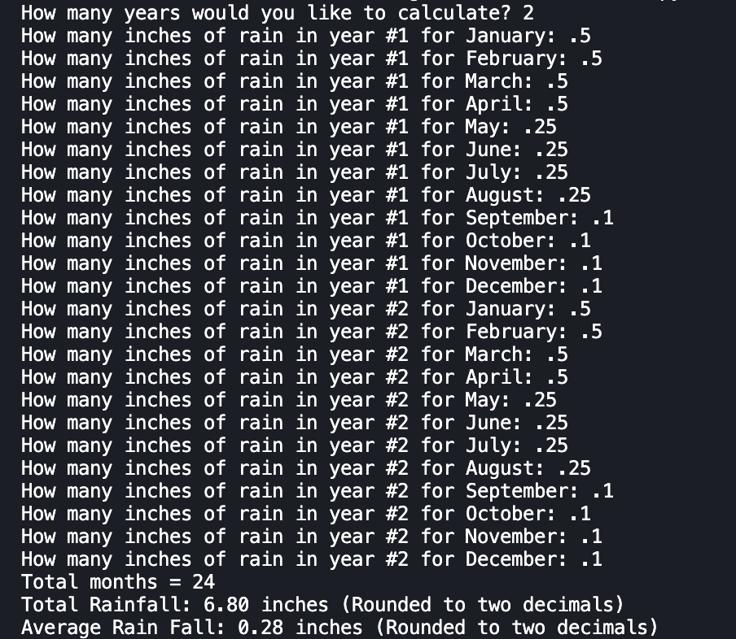

Screen shot of Part 2 executing:

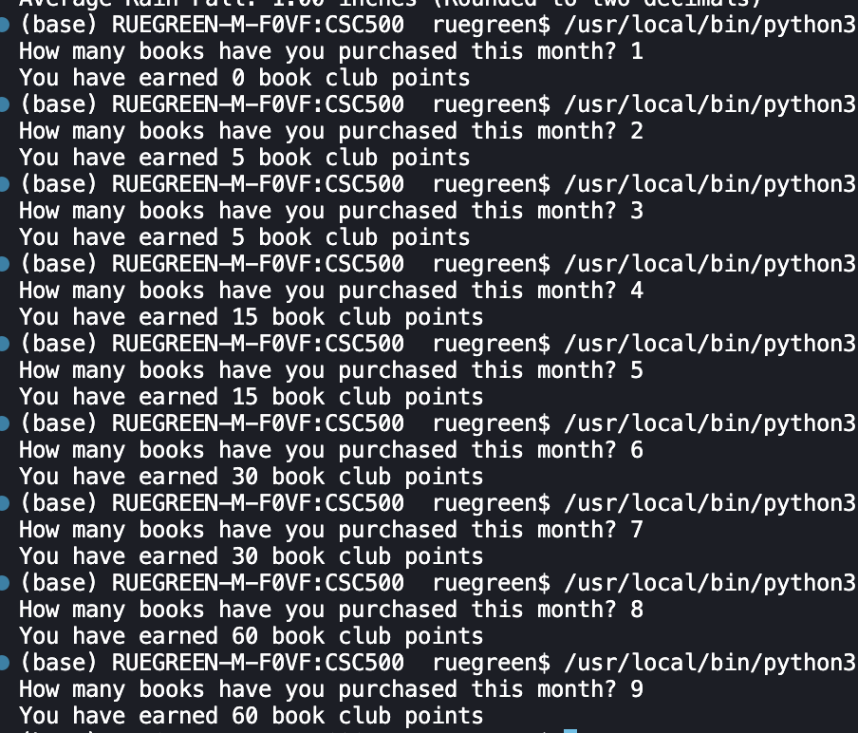

Git hub Public Repo:

Root Public URL: <https://github.com/ruegreen/CSC500/tree/main>

Module 5 URL: [https://github.com/ruegreen/CSC500/tree/main/Module 5](https://github.com/ruegreen/CSC500/tree/main/Module%205)